Q1. **SELECT clause with WHERE, AND, DISTINCT, Wild Card (LIKE)**

**Ans –**

1. select employeenumber,firstname,lastname from employees where jobtitle = 'Sales Rep' and reportsto = 1102;
2. select distinct productline from products where productline like '%cars%';

**Q2. CASE STATEMENTS for Segmentation**

**Ans –**

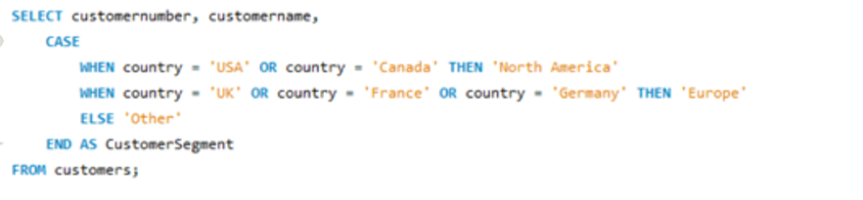

Q3. **Q3. Group By with Aggregation functions and Having clause, Date and Time functions**

Ans-

1. select productcode,sum(quantityordered) as total_ordered from orderdetails group by productcode order by total_ordered desc;
2. select monthname(paymentdate) as payment_month,count(customerNumber) as num_payments from payments group by payment_month having num_payments > 20 order by num_payments desc;

**Q4. CONSTRAINTS: Primary, key, foreign key, Unique, check, not null, default**

**a.** **create table customers(**

**customer_id INTEGER PRIMARY KEY AUTO_INCREMENT,**

**first_name VARCHAR(50) NOT NULL,**

**last_name VARCHAR(50) NOT NULL,**

**email VARCHAR(255) UNIQUE,**

**phone_number VARCHAR(20));**

**b.** **create table orders(**

**order_id INTEGER PRIMARY KEY AUTO_INCREMENT,**

**customer_id integer,**

**FOREIGN KEY(customer_id) references customers(customer_id),**

**order_date Date,**

**Total_Amount DECIMAL(10,2) CHECK (Total_Amount > 0));**

**Q5. JOINS**

**a.** List the top 5 countries (by order count) that Classic Models ships to. (**Use the Customers and Orders tables**)

**Ans –** 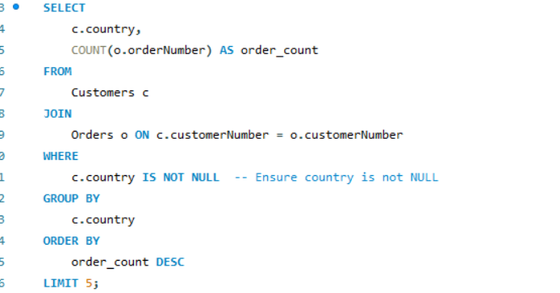

**Q6. SELF JOIN**

**Ans- select mng.fullname as managername,emp.fullname as empname from project as mng join project as emp on mng.employeeid=emp.managerid;**

**Q7. DDL Commands: Create, Alter, Rename**

1. 

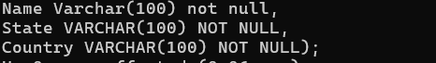

1. 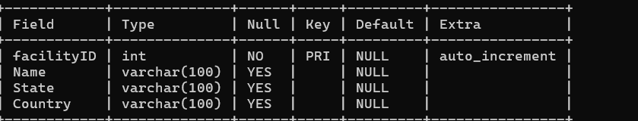
2. 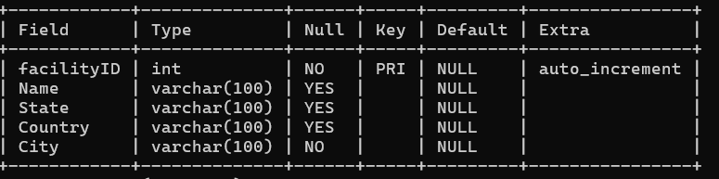

Q8

Ans-

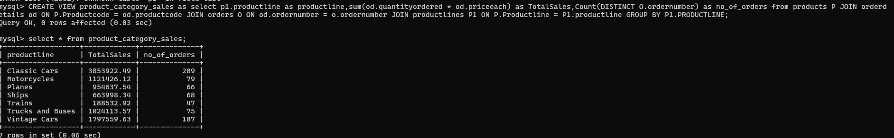

Q9

Ans-

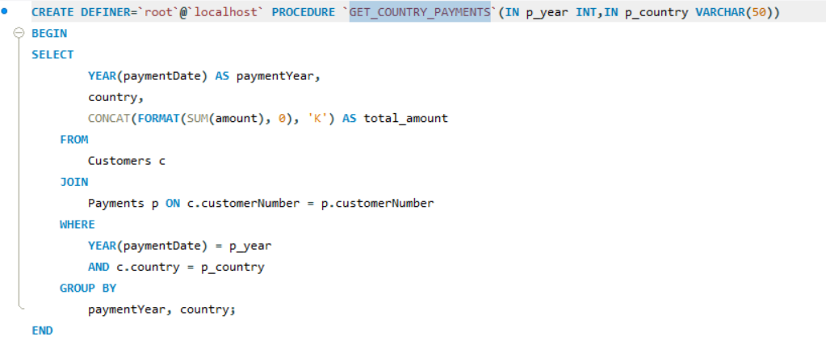

Q10

Ans-

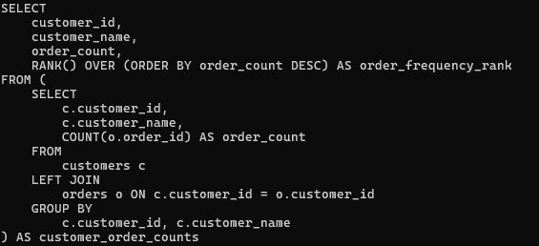

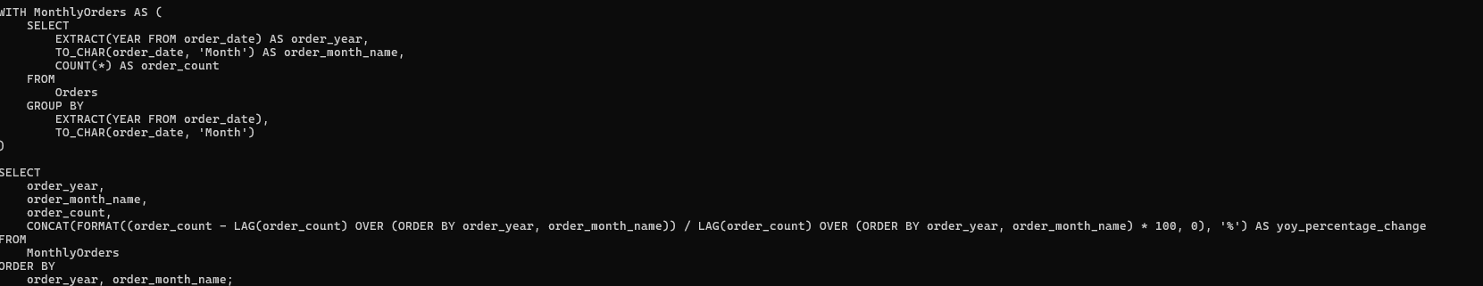

Q11

ANS-



Q12

ANS-

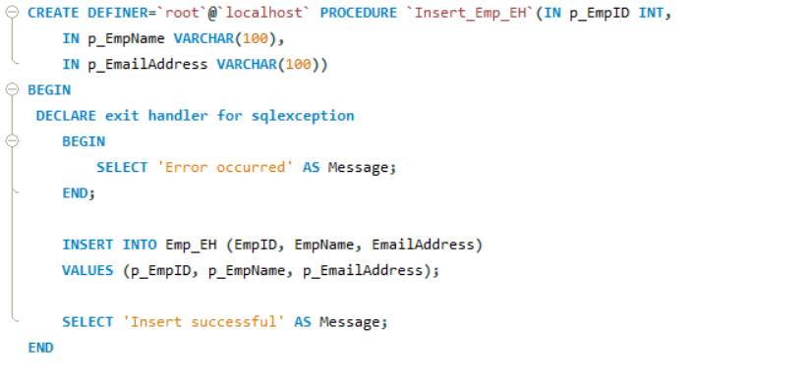

Q13

ANS-

